Click on BLOCKS link on your Home Page (red arrow)
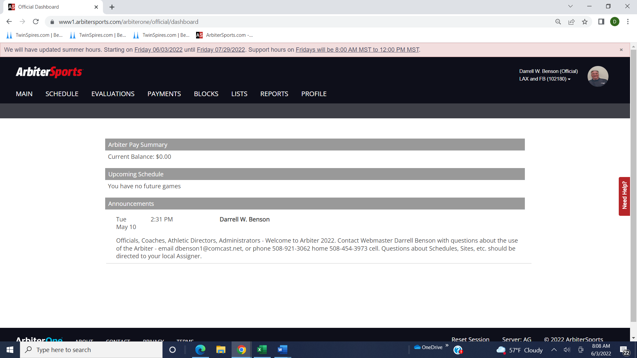

Click on Travel Limits link on the BLOCKS page (green arrow)
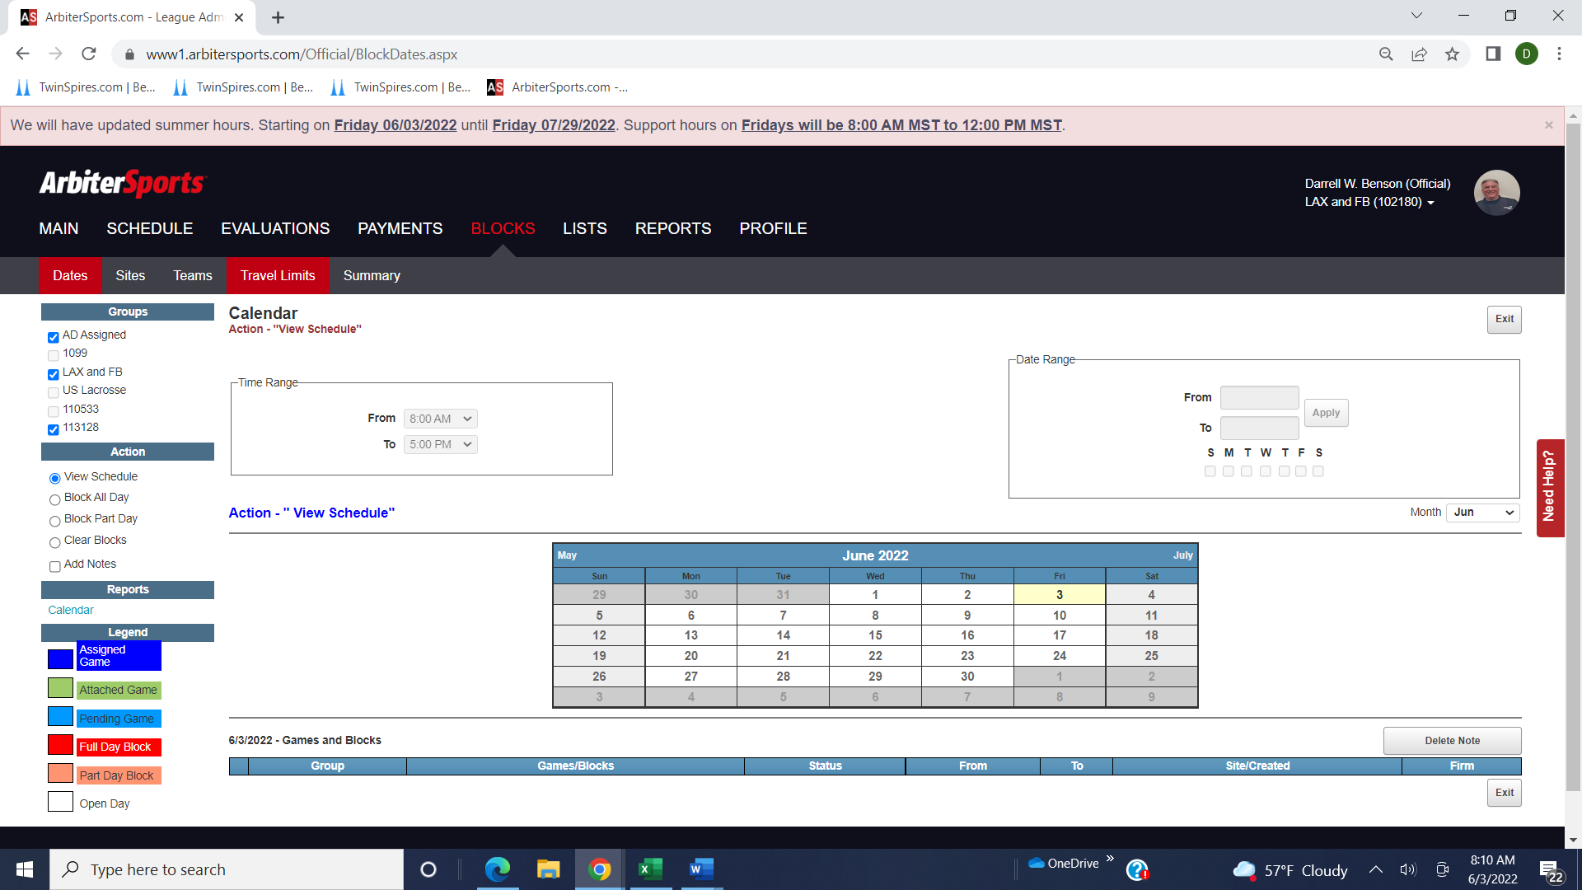

Check the day or days that you want to edit – you can check multiple boxes if they have same zip and mileage. I chose Tuesday (blue arrow), changing to Norwood zip code (orange arrow) and 75 miles (yellow arrow). Then click Apply (green arrow)
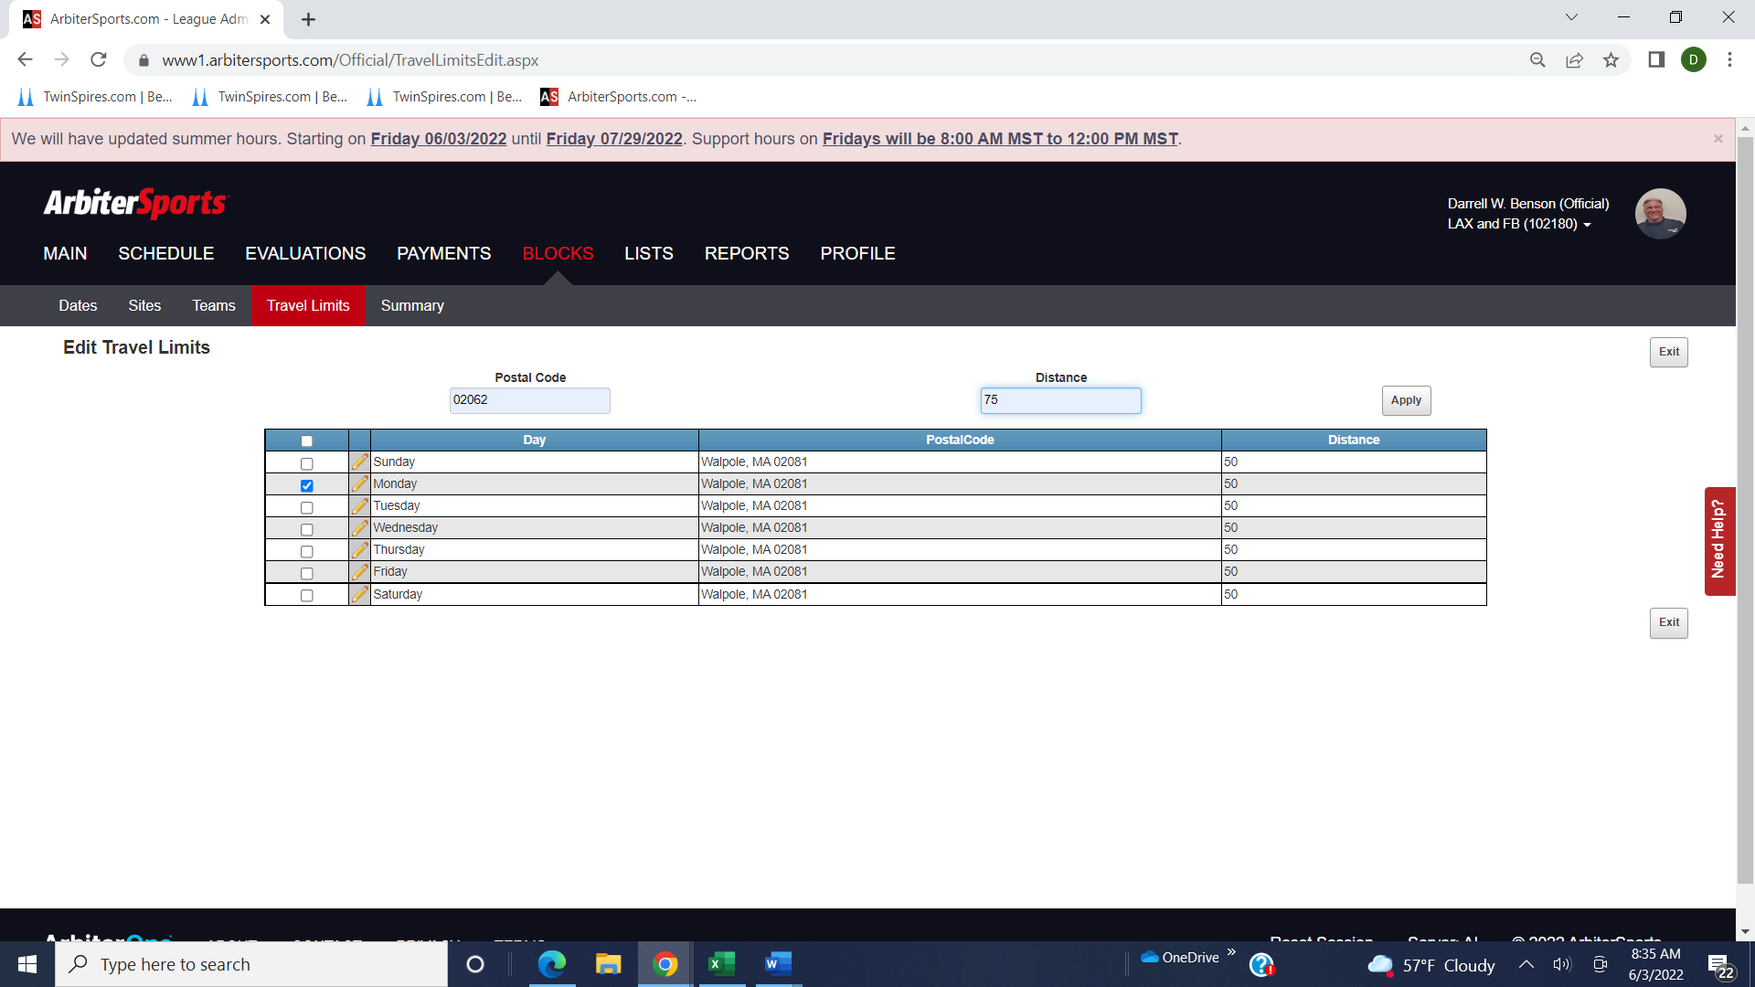

This is edited page showing Tuesday Leave City as Norwood and Travel Limit 75 miles
