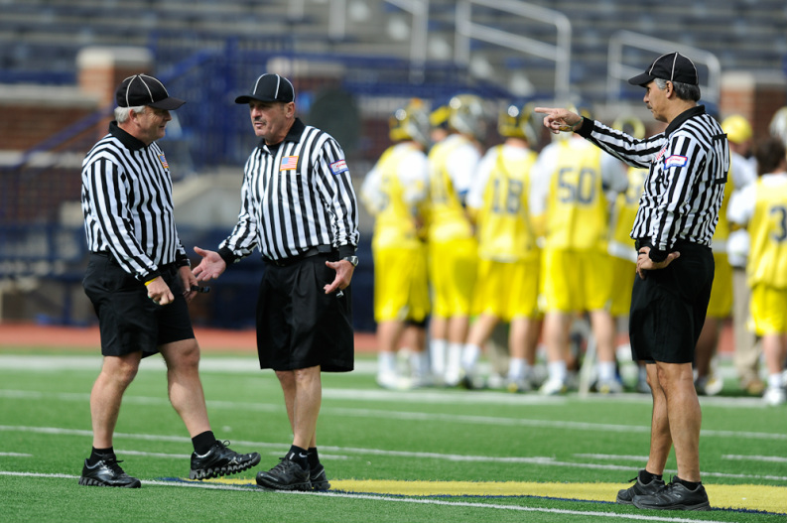
REGULAR SEASON UNIFORM
- Striped Shirts (1 inch vertical black/white stripes with black collar and black cuffs and a pocket on the left breast; long sleeve and short sleeve)
- Undershirt Solid black t-shirt or turtleneck. Any visible undergarments must be black or grey.
- Shorts Solid black with belt loops, no mesh lacrosse or basketball shorts.
- Shoes All black - mark out any white logos or swooshes with a black marker – shined. Cleats are not required, but may be worn on natural grass surfaces.
- Socks All black ankle socks. No calf length black socks.
- Belt 1 1/4 – 2 inches in width, solid black with a plain buckle.
- Hat (black baseball style cap with white piping)- always have a nice hat!
- Fox 40 Finger Whistle (spare optional)
- Digital Wrist Watch Must have countdown timer function.
- Flags Two yellow with black tip
- Scorecard May use a plastic one or a paper one you print out or use an index card.
- Pencil Golf or library pencil is fine. May purchase “bullet pencil” from official’s store.
- Coin (Half-dollar size or larger). EMLOA coins are available to members who have worked two full seasons.
- Cold weather gear Jackets and long pants should be all or predominantly black
Items below are nice to have but not necessary for Associate Officials
- 6’ Mini Tape Measure Not the Bob the Builder size!
- 20-second Timer There are 2 types: the 20 second timers and the 1:40/20 second timers, the latter is great for managing time outs and time between periods.
- Coaches Certification Cards

Patches If you are officiating an EMLOA sanctioned contest you should have an Associate Officials patch on your left shoulder, 3” down from the seam where the sleeve meets the body of the shirt

