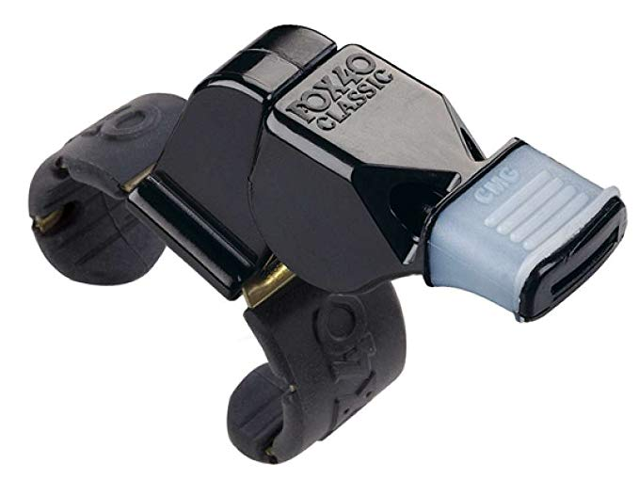
2022
EMLOA
ASSOCIATE OFFICIALS
TRAINING PROGRAM
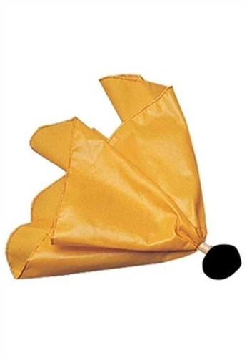

Rev. 1.3
Feb. 22, 2022

Introduction
ASSOCIATE OFFICIALS PROGRAM
- Program History –
  - Now in 16th year.
  - Over 2,200 High School students have participated
- Primary Responsibilities
  - Player Safety
  - Promote Fair Play through Rules Knowledge and Mechanics knowledge

ANNUAL CERTIFICATION REQUIREMENTS
New AO
- Classroom/Remote Training
- Certification Test
- Mentoring
- Ongoing Evaluations

Returning AO
- Classroom/Remote Training
- Certification Test,
- Ongoing Evaluations

AO vs Senior AO
To qualify for Senior AO, you must have at least 2 years of experience as an AO, preferably be a Senior in High School, and have recommendation from your town youth program

2022 POINTS OF EMPHASIS
- Player Safety – Targeting, Hits to the head and neck, Big hits
- Professionalism
- Sportsmanship

NEW RULES for 2022 – NFHS, MBYLL, Other Youth Leagues

YOUTH RULES – Rules Differences
Rules differences for various youth league games can be found on EMLOA website and league website

Section 1
PROFESSIONALISM
Appearance – Always look your best by wearing the proper uniform and keeping it neat and clean. This is what gives coaches and parents their first impression of you as an official.
Timeliness – Being on time means being early. Always show up early and get comfortable.
Rules Knowledge – It takes a long time to fully understand all the rules. Continually review the rules and their application to help you develop more quickly.
Mechanics - In addition to knowing the rules, officials need to know where to go on the field and what their responsibilities are at any given time.
Game Management – There are opportunities in every game when an official can keep a game running smoothly without using a flag or whistle. Some of these will be discussed in class.
Focus – Concentrate on your responsibilities throughout the entire game – don’t lose focus. Try to not get distracted and don’t dwell on a call that you make.
Conditioning – Stay in good shape so you look the part and you can always get to the right position to make your calls
Communication – Communication is a very important part of your job. Constantly communicate with your partner. Use appropriate contact when needed with the players and the coaches.
Conduct – Be respectful at all times. Try to avoid appearing aloof or indifferent
Confidence – Br firm and demonstrative with your calls. Coaches and parents will see you as a more accomplished official than if you are quiet and appear timid.
Consistency – Try to be consistent with your calls on both teams. Also try to stay consistent with your partner – on the same page.
Courage – Try to get it right. Show the courage to make an unpopular call or no-call as long as you are confident that it is the right call.

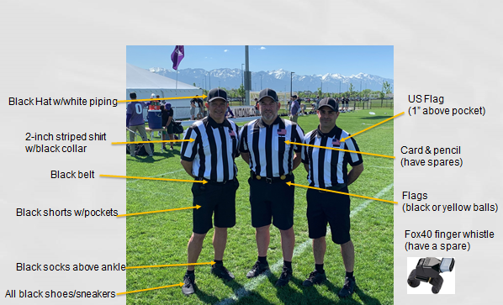
REGULAR SEASON UNIFORM
- Striped Shirts (2 inch vertical black/white stripes with black collar and black cuffs and a pocket on the left breast; long sleeve and short sleeve)
- Undershirt Solid black t-shirt or turtleneck. Any visible undergarments must be black or grey.
- Shorts Solid black with belt loops, no mesh lacrosse or basketball shorts.
- Shoes All black - mark out any white logos or swooshes with a black marker – shined. Cleats are not required, but may be worn on natural grass surfaces.
- Socks All black ankle socks. No calf length black socks.
- Belt 1 1/4 – 2 inches in width, solid black with a plain buckle.
- Hat (black baseball style cap with white piping)- always have a nice hat!
- Fox 40 Finger Whistle (spare optional)
- Digital Wrist Watch Must have countdown timer function.
- Flags Two yellow with black tip
- Scorecard May use a plastic one or a paper one you print out or use an index card.
- Pencil Golf or library pencil is fine. May purchase “bullet pencil” from official’s store.
- Coin (Half-dollar size or larger). EMLOA coins are available to members who have worked two full seasons.
- Cold weather gear Jackets and long pants should be all or predominantly black
Items below are nice to have but not necessary for Associate Officials
- 6’ Mini Tape Measure Not the Bob the Builder size!
- 20-second Timer There are 2 types: the 20 second timers and the 1:40/20 second timers, the latter is great for managing time outs and time between periods.
- Coaches Certification Cards

Patches If you are officiating an EMLOA sanctioned contest you should have an Associate Officials patch on your left shoulder, 3” down from the seam where the sleeve meets the body of the shirt

Section 2 PLAYER SAFETY
Big Hits
Big Slashes
Defenseless Players
Targeting
Fights

Section 3 LACROSSE DEFINITIONS AND TERMINOLOGY
Field and Lines– refer to field layout on next page
Officials and Responsibilities
Lead Official and Trail Official
On Official and Off Official
Also
Referee and Umpire
Faceoff Official and Wing Official
PLAY ON TECHNIQUE If a player commits a loose-ball or line violation foul, goalie interference or crease violation and the offended player may be disadvantaged by the immediate suspension of play, the official will delay the whistle and signal play-on.
SLOW-WHISTLE TECHNIQUE If a defending player commits a foul against an attacking player and an attacking player has possession of the ball, the official must drop a flag, make the verbal signal “flag down” and withhold his whistle until:
a) A goal is scored by the attacking team.
b) The ball goes out of bounds.
c) A player on the defending team gain possession of the ball.
d) An injury occurs to a player on either team and is deemed by the official to be serious enough for an immediate whistle.
e) A player loses any of the required equipment in a scrimmage area, or a player is injured in a scrimmage area, and the official is required under the rules to blow the whistle.
f) The attacking team commits a foul.
g) The ball is in the defensive half of the field and the team in possession fails to clear the ball into the goal area. h) When the ball hits the ground (not on a shot), the slow whistle is terminated.
i) The defensive foul is committed during the last two minutes of regulation play with the team that is ahead unless a scoring play is imminent. j) A shot hits the goalkeeper, goal posts, or crossbar, the ball is touched by any player of either team other than the defending goalkeeper, or an official.
MECHANICS – Review 1 Man, 2 Man mechanics
SIGNALS – Review Administrative signals and Foul signals
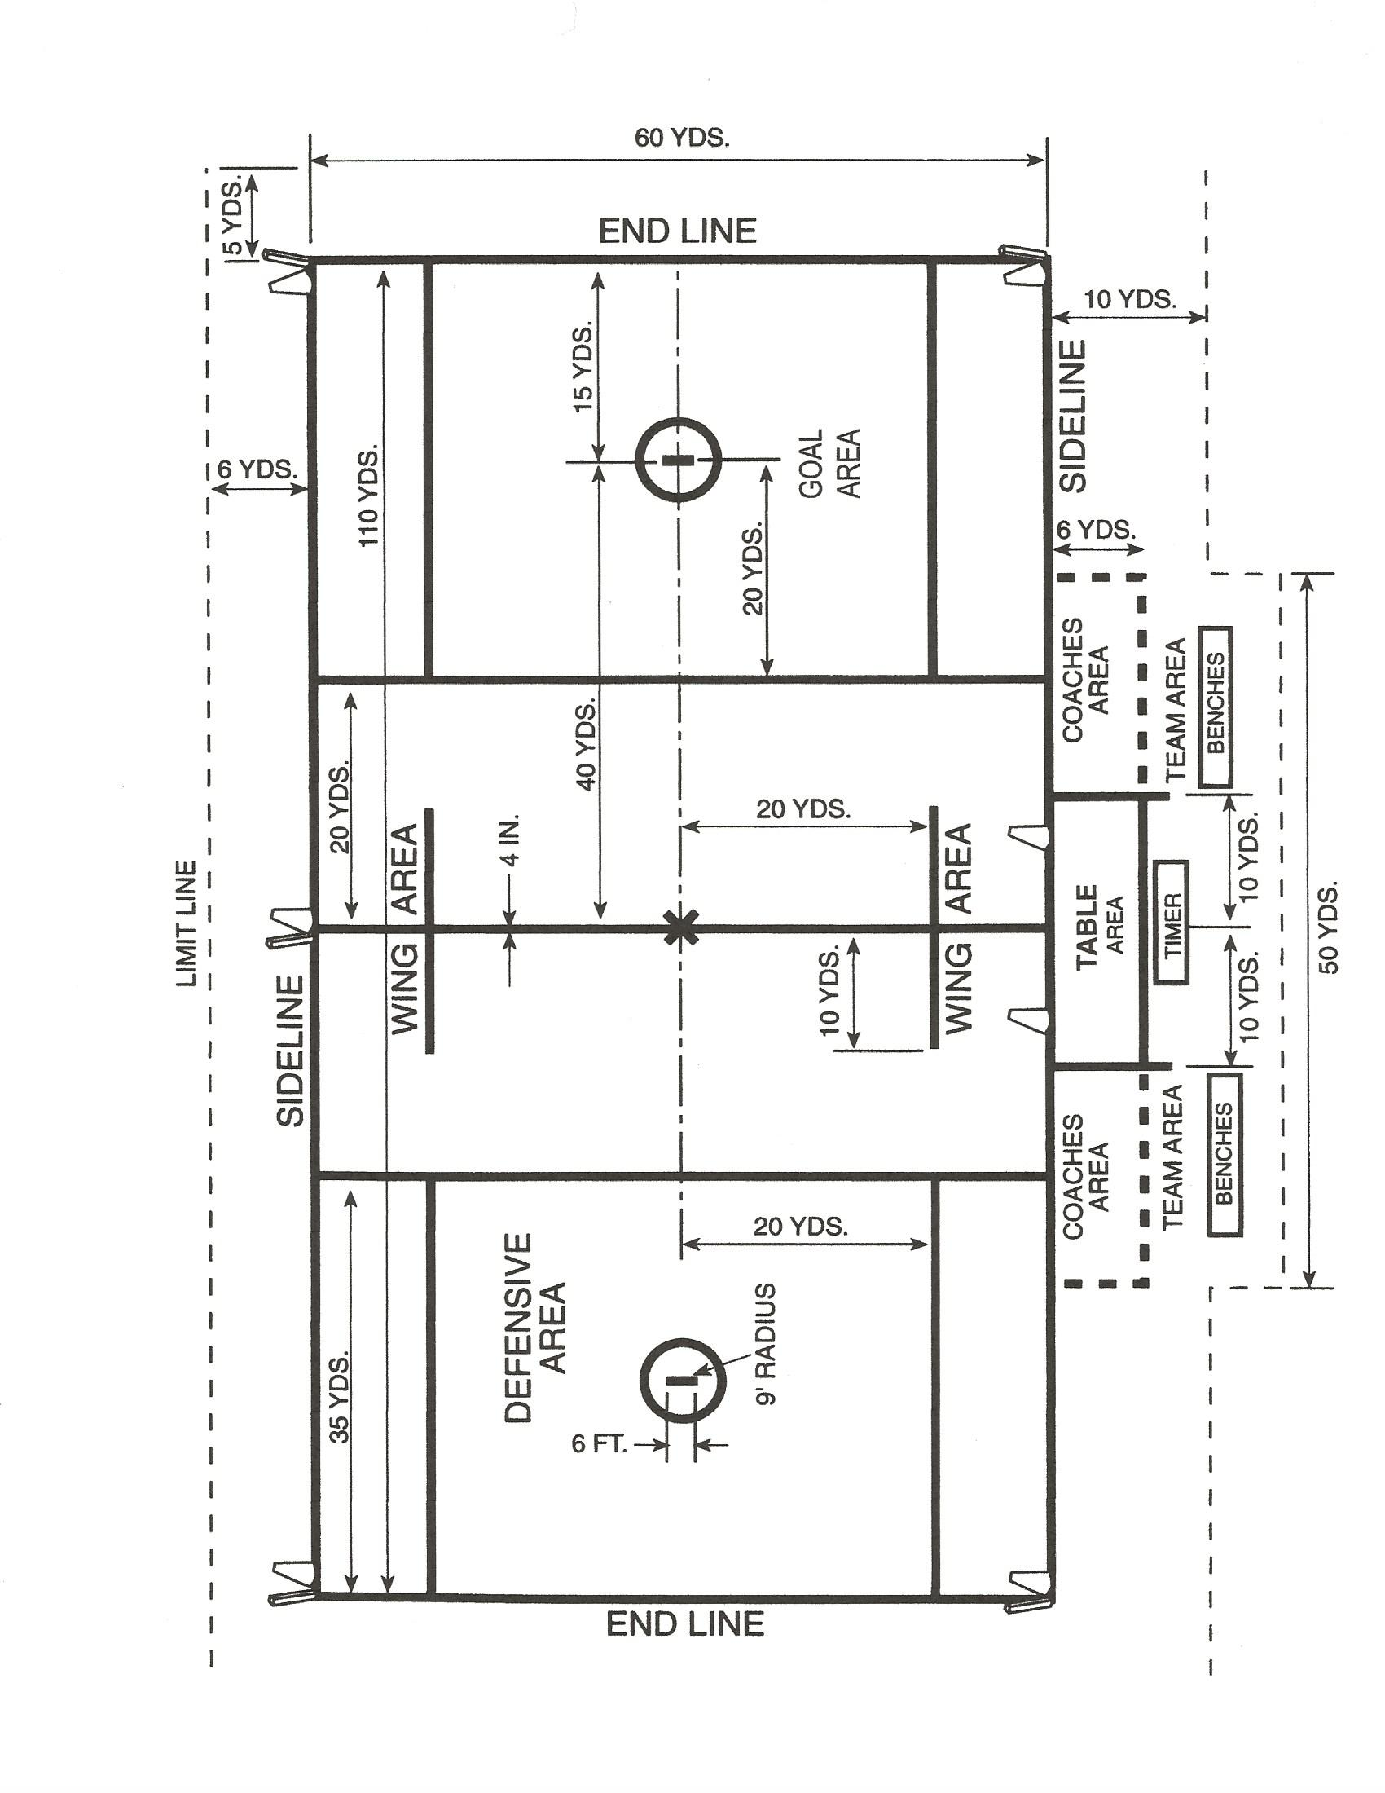

Section 4 PLAY OF THE GAME
PRE-GAME – Coaches Meeting, Coaches Certification
COIN TOSS – Team Captains - A coin-toss will be used to determine first alternating possession or choice of goal.
LINEUP - Before the start of play, the official shall bring all the players on both teams in lines facing each other at the center of the field, with their left sides toward the goal they are defending, and explain any special ground rules, emphasize safety, fair play, and sportsmanship. After the lineup, all the players other than the starters will return to their team areas.
FACEOFFS - Play shall start at the beginning of each period and after each goal with a faceoff at the center spot. The official will conduct a faceoff with one player from each team.
ADVANCING THE BALL (a) Over the Midline (20 seconds) - Upon gaining possession of the ball inside the defensive half of the field, a team shall advance the ball beyond the center line within 20 seconds or there will be an immediate turnover.
(b) Into the Goal Area (10 seconds) - Upon the ball being possessed in a team’s offensive half of the field, a team shall advance the ball into the goal area within 10 seconds or there will be an immediate turnover. Additionally, once the 10-second count has been satisfied and an offensive team carries, passes or propels the ball over the midline (except on a shot) it will result in an immediate turnover.
Once started, both the 20 and 10 counts will continue until:
• The opposing team gains possession.
• A clearing team player in possession of the ball steps on or over the line.
• The official sound the whistle to stop play for any reason.
• The ball physically touches anything in the Goal Area.
• Play-on
• A loose ball crosses over the midline (20 second count only)

SETTLED PLAY Settled offense is nothing more than players using set offensive plays or “formations” that incorporate basic offensive principles to create scoring opportunities around the goal area. Players need to recognize that if they are not able to exploit a numeric advantage, they must slow down the play and settle into a formation.
Players need to learn basic offensive principles in order to execute any offensive formation. As players run the settled offense, they use their basic individual skills to get past their defender with or without the ball.
TRANSITION
When play becomes unsettled, meaning the ball goes loose or gets turned over, it may end up in a transition situation. This simply means the ball is now going in a different direction and players will start substituting off the field and their substitutes will start coming on the field.

RESTARTS
Following a Shot – award to the player closest to the ball where and when the ball the ball went out of bounds
Following Ball Out of Bounds – award to the team that did NOT last touch the ball or if a player in possession touches the line or steps out of bounds, blow the whistle and award the ball to the other team. Restart close to the spot where the ball went out. Restarts should be “fast but fair”.
Following a Timeout - Restarts following a timeout shall be nearest the spot where the ball was at the time the whistle was blown or if the ball is within fifteen yards of the goal, it shall be restarted laterally five yards from the sideline nearest to the spot of the ball at the time of the whistle. Make sure the correct number of players are on the field.
Section 4 PLAY OF THE GAME – cont.
5 Yard Restart Rule – New in 2020 – No offensive player may be within 5 yards of teammate who is restarting the ball. No defensive player may “play” the player restarting the ball until he ha established a 5 yard separation.

CREASE PLAY DO’s AND DON’Ts
CREASE VIOLATIONS/GOALKEEPER INTERFERENCE:
When the defensive team has possession of the ball, infringements of the rules involving the crease shall be penalized as follows (rather than under the general rules for technical fouls):
a. Any crease violation or interference with the goalkeeper of a technical nature while the ball is in possession of the defensive team outside of the crease shall result in a slow-whistle, flag-down situation. b. Any crease violation or interference with the goalkeeper while he and the ball are in the crease, whether or not he has possession of the ball, shall be a play-on. If the goalkeeper has possession and fails to run the ball out of the crease or successfully complete an outlet pass, the ball is awarded to his team in its offensive side of the field at the Center. If the ball is loose in the crease and the goalkeeper gains possession, the play-on is over.
GOAL-CREASE PROHIBITIONS No offensive player may enter the crease at any time. Offensive players may reach their stick into the crease for the sole purpose of collecting a loose ball.
Penalty: Technical foul for the offensive player
GOALS – Exchange ends after each quarter.
SUBSTITUTIONS – During live ball play, player must be off the field before substitute can enter the field. Keep the substitution area clear – no coaches or players should be hanging out in the substitution area during play
GOAL DIFFERENTIAL – In High School, there is a 12 goal differential that determines what happens next as far as a faceoff or clear. Many youth leagues have a 6+ Goal rule – see youth league handout for specific rule.
LONG POLES – The Youth rules vary from league to league and by age level. General rule is, the older the boys, the longer their long poles can be. At the youngest levels, the typically may only use short sticks and some cases, the may be shorter than the high school short sticks - see youth league handout for specific rule.

Section 5 FOULS
There are two categories of fouls in boy’s lacrosse – Personal Fouls and Technical Fouls.

PERSONAL FOULS
Personal fouls are the more serious fouls and need to be called at all times, regardless of score or situation. These are the Player Safety type fouls that involve illegal contact and sportsmanship fouls that involve bad behavior. Illegal equipment fouls also fall into the Personal Foul category.

ENFORCEMENT - Personal fouls can result in a one minute, two minute or three minute time-serving penalty. Most of the more violent, physical hits can be non-releasable fouls. If a player accumulates a certain number of personal foul penalty minutes or personal fouls, he shall be disqualified from the game. High school and youth rules have different criteria for this. In High School it is five penalty minutes – refer to handout for youth rule.

SLASHING:
- Swinging a crosse at an opponent’s crosse or body with deliberate viciousness or reckless abandon, regardless of whether the opponent’s crosse or body is struck.
- Striking an opponent in an attempt to dislodge the ball from his crosse, unless the player in possession, in an attempt to protect his crosse, uses some part of his body other than his head or neck to ward off the thrust of the defensive player’s crosse and, as a result, the defensive player’s crosse strikes some part of the attacking player’s body other than his head or neck. NOTE: Contact of any degree made to an opponent head while actively making a stick check is a slashing penalty.
- Striking an opponent in any part of the body with the crosse (including its end cap), except when done by a player in the act of passing, shooting or attempting to scoop the ball. In all situations, the player’s gloved hand shall be considered part of the crosse, except when in contact with a line marking.
- One-handed checks shall be considered a slash, whether or not it makes contact with the opposing player. If the defensive player’s hand comes off his stick in his legitimate follow through motion after, or during his recovery from, a controlled poke check, this need not be considered a slash solely because his hand came off the stick.

UNNECESSARY ROUGHNESS:
(1) An excessively violent infraction of the rules against holding and pushing. (2) Deliberate and excessively violent contact made by a defensive player against an offensive player who has established a screening position. (3) Any avoidable act on the part of a player that is deliberate and excessively violent, whether it be with the body or crosse. This may include a legal body check.
PENALTY: Penalty for unnecessary roughness fouls are a One, Two, or Three-minute non releasable foul, at the official’s discretion. An excessively violent violation of this rule may result in an ejection.

CHECKS INVOLVING THE HEAD/NECK:
(1) A player shall not initiate contact to an opponent’s head or neck with a cross check or any part of his body (head, elbow, shoulder, etc.). Any follow-through from these actions that contacts the head or neck shall also be considered a violation of this rule.
(2) A player shall not initiate an excessive, violent or uncontrolled slash to the head/neck.
(3) A player, including an offensive player in possession of the ball, shall not block an opponent with the head or initiate contact with the head (known as spearing).

ILLEGAL BODY CHECK:
(1) Body-checking of an opponent who is not in possession of the ball or within three yards of a loose ball.
(2) Body-checking of an opponent from the rear, at or below the waist, or above the shoulders
(3) Body-checking of an opponent who has any part of his body other than his feet on the ground.
(4) A body check that targets a player in a defenseless position. This includes but is not limited to: (A) body checking a player from his “blind side”; (B) body checking a player who has his head down in an attempt to play a loose ball; and (C) body checking a player whose head is turned away to receive a pass, even if that player turns toward the contact immediately before the body check.
(5) An Excessive Body-Check in which the player lowers his head or shoulder with the force and intent to put the other player on the ground. (Note: If a player who is about to be body-checked turns his back, jumps or moves in such a manner to make what started out to be a legal check appear illegal, no foul is committed by the player applying the body-check)

CROSS CHECK: a player may not check his opponent with that part of the handle of the crosse that is between the player’s hands, either by thrusting away from the body or by holding it extended from the body.

TRIPPING – A player may not trip an opponent with any part of his body or his crosse.

UNSPORTSMANLIKE CONDUCT (Non Releasable):
(1) Unsportsmanlike conduct by coaches and/or players will not be tolerated. Obscenities need not be used for language to draw a penalty. Tone, disruptiveness, and body language can all contribute to unsportsmanlike conduct. Players and coaches will exhibit the highest level of sportsmanship at all times. Note: US Lacrosse discourages any form of taunting which is intended to embarrass, ridicule, or demean others. This can include but is not limited to race, religion, gender, national origin, or any other basis.
(2) No player, substitute, nonplaying member of a squad, coach or spectator shall:
a*. Enter into an argument with an official as to any decision that has been made or in any way attempt to influence the decision of an official.
b*. Use threatening, profane or obscene language or gestures at any time during the game.
c*. Bait or call undue attention to oneself, or any other act considered unsportsmanlike by the officials.
d. Deliberately use his hand or fingers to play the ball or grab an opponent’s crosse with the open hand or fingers on a faceoff. (Note: Inadvertent touching of the ball when the hand is grasping the stick on a faceoff should not be called as an unsportsmanlike conduct foul).
*Note: If a spectator is verbally abusive to players, coaches, or game officials, the official will suspend the game and instructs both coaches to address the spectator in question. If the conduct by the spectator continues the team associated with the offending spectator shall be assessed a 1 minute non-releasable unsportsmanlike conduct penalty. Any continued unsportsmanlike behavior by the spectator can result in Game Termination.

ILLEGAL EQUIPMENT – player must be wearing all of the mandatory equipment and that equipment must be legal.

ILLEGAL CROSSE – New in 2020- Any crosse (stick) deemed illegal (e.g., too short, too long, too narrow, illegal shooting strings, deep pocket, etc.) is subject to a two minute non-releasable penalty.

TECHNICAL FOULS
Technical fouls are those of a less serious nature than personal fouls and include all other violations that are not listed as personal fouls. These are referred to as “game management” fouls.
ENFORCEMENT - Technical fouls are administered in 3 ways
- Flag – 30 second foul if team with possession of the ball is offended.
- Change of Possession (COP) – if team in possession commits the foul, stop the play and give the ball to the other team
- Award – if the ball is loose, and offended team is not going to gain possession (following Play-on), stop the play and award the ball the team that was offended.

DELAY OF GAME – New in 2020 – Not providing 5 yard clearance on a restart.
PUSH: A player shall not thrust or shove an opponent from the rear. A push is exerting pressure after contact is made and is not a violent blow. Pushing is permitted from the front or side when an opponent has possession of the ball or is within 3 yards of a loose ball. In this case, pushing shall be done with either closed hand, shoulder, or forearm, and both hands shall be on the crosse.
HOLD: A player shall not impede the movement of an opponent or his crosse. Hold is considered illegal under the following conditions:
a. Use the portion of the handle that is between his hands to hold an opponent.
b. Step on the crosse of an opponent.
c. Hold an opponent with his crosse.
d. Hold or pin an opponent’s crosse against the body of the opponent with his crosse.
e. Hold an opponent with his free hand that is off the crosse.
f. Hold the crosse of the opponent using any part of his body.
g. Use his crosse to hold or pin an opponent’s crosse to the ground on a face-off.

OFFSIDE: A team is considered offside when a team has more than 6 players in its offensive half of the field or more than 7 players in its defensive half of the field.
INTERFERENCE: A player shall not interfere in any manner with the free movement of an opponent, except when that opponent has possession of the ball, the ball is in flight and within 3 yards of the players, or both players are within 3 yards of a loose ball.
WARDING OFF: A player in possession of the ball shall not use his free hand or arm or any other part of his body to hold, push or control the direction of the movement of the crosse or body of the player applying the check. A player in possession of the ball may protect his crosse with his hand, arm or other part of his body when his opponent makes a play to check his crosse.
ILLEGAL OFFENSIVE SCREEN: No offensive player shall move into and make contact with a defensive player with the purpose of blocking a defensive player from the man he is playing, nor shall the offensive player hold his crosse rigid or extend his crosse rigid to impede the normal movements of the defensive man. If contact is made between offensive and defensive players as a result of the offensive player’s setting a screen, the offensive player shall be stationary before the contact occurs, with his feet no wider than shoulder-width apart.

ILLEGAL PROCEDURE: Any action on the part of players or substitutes of a technical nature that is not in conformity with the rules and regulations governing the play of the game shall be termed illegal procedure.
The following are examples of illegal procedure:
a. Touching the ball – A player shall not touch the ball with his hands while it is in play. The exception is the goalkeeper while both he and the ball are inside the crease.
b. Illegal actions with crosse – A player shall not: 1. Throw his crosse under any circumstances. 2. Take part in the play of the game in any manner without his crosse when (a) a player lose his crosse in any legal way, so that repossession of the crosse would cause him to violate a rule, the slow-whistle shall be employed by an official
(b) Should a crosse be in the crease so as to possibly interfere with the goalkeeper’s play of an attempted shot at the goal, play shall be suspended immediately. 3. Intentionally kick an opponent’s crosse.
c. Crosse in face of opponent – A player shall not push at, thrust or flick his crosse in the face of an opponent.
d. Avoidable lateness of team – When a team fails to appear on the field ready to play at the appointed time for the start of a contest, and this tardiness is avoidable.
e. Entering the game from the penalty area before authorized to do so by the timekeeper. The player shall be returned to the penalty area to serve his remaining time, plus 30 seconds. If the ball is loose or in possession of the player’s own team, it shall be awarded to the opposing team and the player leaving the penalty area early does not have to serve an additional 30 seconds. In the event that a goal is scored by the opponent, the unexpired penalty time is nullified, and the 30-second penalty is erased.
f. Delaying the game – When it is a team delay, the penalty shall be assigned to the in-home. Delaying the game shall be the consuming of more than 20 seconds:
g. Participation in the play of the game by a player out of bounds.
h. Any player not in his restraining area at the time the whistle is blown to start play at the time of a faceoff.
i. Failure to remain 5 yards from a player awarded the ball for a restart.
j. Any violation of the rules for substituting players.
k. Any violation of the rules relating to the goal-crease area.
l. Any violation of the rules for time-outs.
m. Having more than 10 players in the game at any time, including a player or players in the penalty area.
n. Violation of the rules on positioning for a faceoff. Award the ball to offended team in its offensive side of the field at Center. (See Rule 7.3)
o. If a head coach makes two or more requests in which no violations are found for either counting of long crosses or inspecting any opponents’ equipment, a time-out will be charged. If no time-outs remain for that half or overtime period, a technical foul will be called.
p. Having more than four long crosses in the game.
q. Failure of the player in possession of the ball to place the ball directly on the field or hand it to the nearest official on a change of possession. An example is if the player rolls the ball away or creates a delay or disadvantage to the team being awarded the ball.
r. Failure to advance the ball beyond the center line into the goal area within 10 seconds as required, or upon gaining possession of the ball inside the defensive half of the field, to advance the ball beyond the center line within 20 seconds.
s. Failure to provide a scorebook, timing device, table and working horn.
t. Failure to have a clearly marked center line that runs the entire width of the field.
u. Failure to have a properly equipped designated goalkeeper on the field of play.
v. When no player from the team awarded possession picks up the ball and moves to the position of the restart within five seconds after the officials are ready to restart play.
w. Take a dive or feign a slash to the head or body in order to deceive the official and draw a penalty.
x. Failure to wear required mouthpiece (unless it comes out during play).

Other Technical Fouls – Stalling, Withholding ball from play

Wrap up
ASSOCIATE OFFICIALS CHECKLIST
Keep all Receipts – your town may reimburse you for some or for all your expenses

EMLOA Registration and Dues (check, online, cash) ____________
Sign Up and Attend Class ____________
Test ____________
Order Uniform ____________
Register on MBYLL ____________
Mentoring (new AO’s) ____________

Relevant Websites
www.emloa.org
www.mbyll.org
www.tpllax.com
www.blowyourwhistles.com

